Supplemental Materials
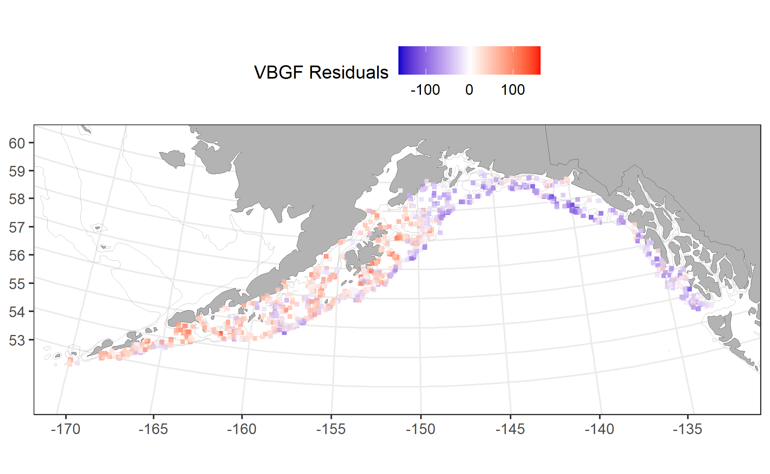

Figure S1. Residuals from single-area, sex-specific von-Bertalanffy growth curves fit to survey age-length data plotted by location for males and females combined. Positive residuals are plotted in red indicating data points where length-at-age was larger than the mean (red) and smaller than the mean (blue). The points are shaded to indicate the size of the residuals (residuals are not standardized).

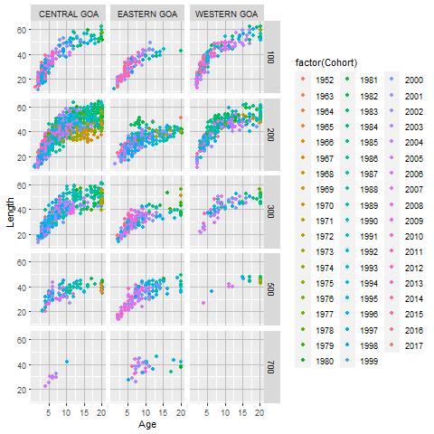
Figure S2. Female age-length data from the GOA trawl survey by cohort (color), management area (columns), and depth (rows). Data points are jittered to show approximate relative number of samples.
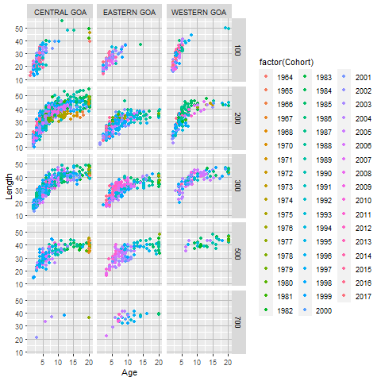

Figure S3. Female age-length data from the GOA trawl survey by cohort (color), management area (columns), and depth (rows). Data points are jittered to show approximate relative number of samples.

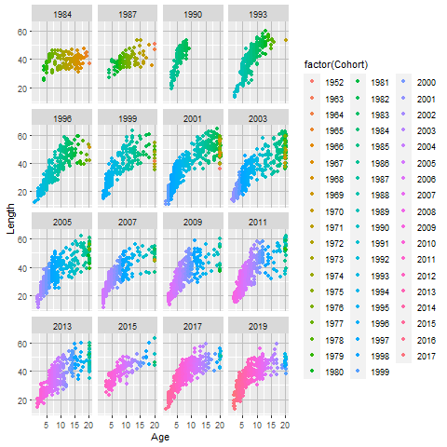

Figure S4. Female age-length data from the GOA trawl survey by cohort (color) and year. Data points are jittered to show approximate relative number of samples.
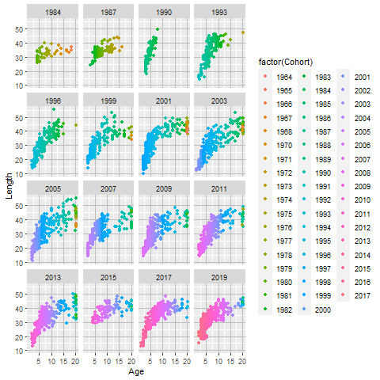

Figure S5. Male age-length data from the GOA trawl survey by cohort (color) and year. Data points are jittered to show approximate relative number of samples.

